FTP upgrade instructions

1, First, we need to build a FTP server, create a user name and password, and specify a root directory for this user.；

2, Create a folder in the user directory of the root of the FTP server“mdvr_filelist”；

3, Put the upgrade configuration file to“mdvr_filelist”directory，like following：
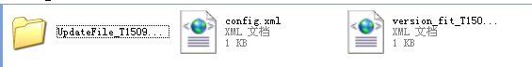
4, Put the *.CRC upgrade file to the UpdateFile_## folder, it is recommended to change the name of the file or folder to upgrade version of the file name, for example“UpdateFile_T15092113”
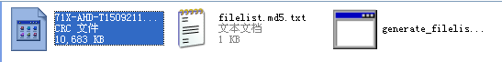
5, Run the "generate_filelist.exe" under the to generate the MD5 check file, open the MD5 file, check if the file name is normal.
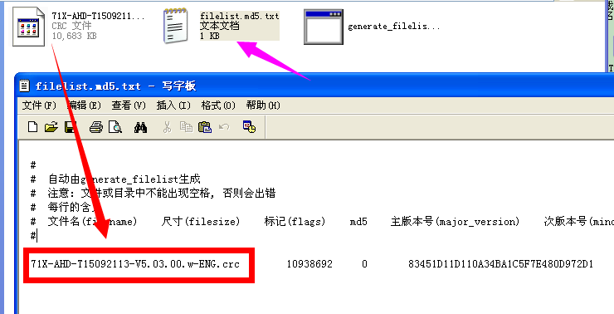
6, Use Notebook to open the "<version_fix_file>, add the upgrade folder name in the middle of <version> ### </version>. In the middle of the <sim_num>###</sim_num>, add the upgrade device's SIM card number, use "," to separate multiple devices.
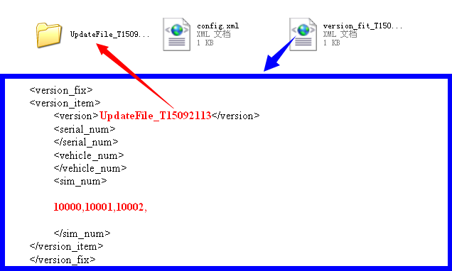

7, Use notebook to open“config.xml”，Add“version_fit_##.xml” name in the middle of <version_fix_file> ### <version_fix_file>.
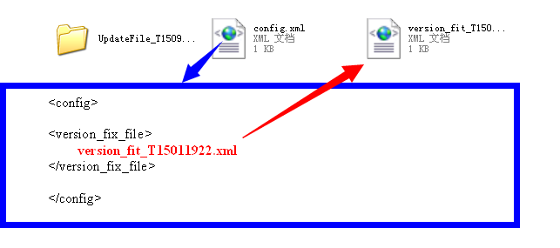

8, After the device is online, if the version is not the same, it will automatically download and check the upgrade file.
